SmartForms – Business Entity Definitions
1. Customer
Definition:
The Customer is the individual or organization that subscribes to and pays for the SmartForms product or services. This entity holds the commercial relationship with SmartForms.
Examples:
• A small business owner subscribing to SmartForms Pro Plan to create client intake forms.
• A university purchasing SmartForms licenses for their departments.
Key Attributes:
• Owns billing account/subscription.
• Can assign roles (consumer/user) within their account.
• Has administrative control over product usage, access, and settings.
• May be an organization (with teams) or an individual.

2. Consumer (Author / Creator / Reviewer)
Definition:
The Consumer is the primary operator of the product — the one who creates, manages, reviews, and publishes forms using SmartForms. They use the product to produce value for their end-users.
Sub-Roles:
Role | Description
Author/Creator | Designs and builds forms using the SmartForms builder (e.g., drag-and-drop interface).
Reviewer | Reviews, tests, and validates forms before publishing. May be a part of a review workflow in teams.
Examples:
• A product manager designing a feedback form.
• An HR professional reviewing a job application form before it’s published.
Key Attributes:
• Has access to the SmartForms builder.
• Can collaborate with other team members.
• May belong to the same customer account (organization).

3. User
Definition:
The User is the end-recipient who interacts with the published forms — typically by viewing, filling, or submitting responses. They do not require a SmartForms account to participate.
Examples:
• A job applicant filling out a SmartForms-powered form.
• A customer submitting feedback through a form embedded in a website.
Key Attributes:
• Interacts with the form externally (front-end interface).
• May be anonymous or optionally identified (email, user ID).
• No access to the form builder or internal platform.

Relationship Summary
Role | Platform Access | Form Creation | Form Consumption | Billing Relationship
Customer | ✅ Full Access | ✅ May create | ✅ May use | ✅ Yes
Consumer (Author/Reviewer) | ✅ Full Access | ✅ Yes | ✅ May test | ❌ No
User | ❌ No Access | ❌ No | ✅ Yes | ❌ No

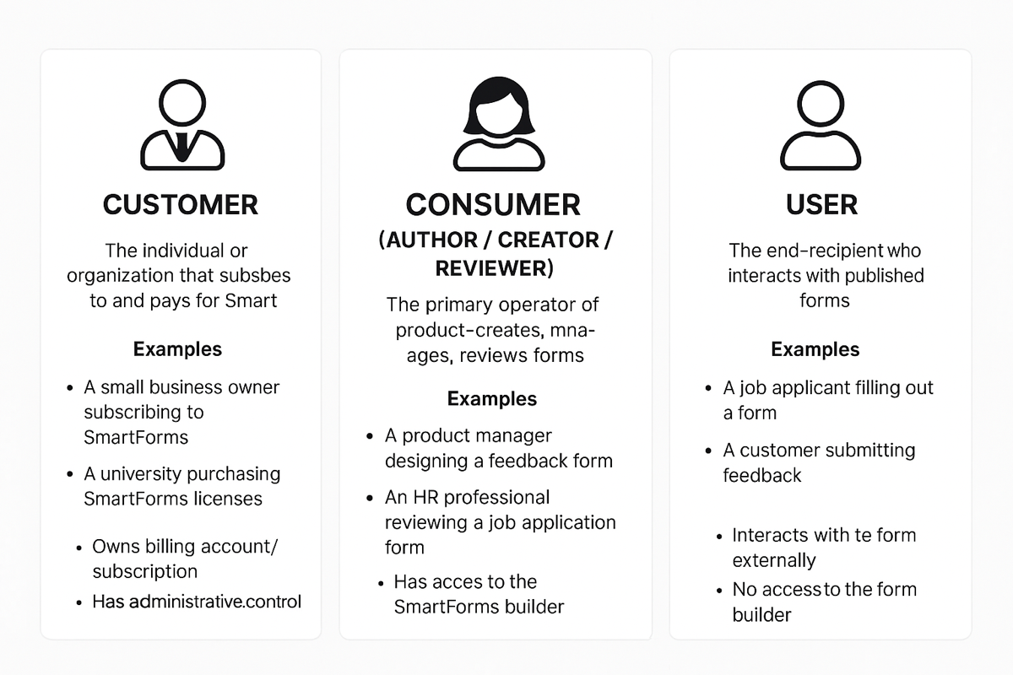

Data Definitions
1. formRawData
Definition:
formRawData represents the structure, layout, and metadata of the form designed by the form creator. It includes the UI configuration, styles, and all embedded components required to render the form on the frontend.
Purpose:
Used to render the form exactly as designed, ensuring visual consistency and logic (e.g., conditional visibility, validations).
Stored As:
JSON format in the database, containing:
• HTML layout or virtual DOM representation.
• Element types and properties (e.g., text field, dropdown).
• Labels, placeholders, default values.
• Style classes, colors, width/height.
• Logic rules (e.g., required fields, conditional display).
• Field identifiers (used to map user responses).
Example:
- Represents the full structure, layout, styles, and metadata of the designed form.
{
"formId": "contact-form-v1",
"title": "Contact Us",
"description": "We would love to hear from you. Please fill out this form.",
"html": "<form id='contactForm'>\n <div class='form-group'>\n <label for='fullName'>Full Name</label>\n <input type='text' id='fullName' name='fullName' placeholder='Enter your full name' required />\n </div>\n <div class='form-group'>\n <label for='email'>Email</label>\n <input type='email' id='email' name='email' placeholder='Enter your email address' required />\n </div>\n <div class='form-group'>\n <label for='message'>Message</label>\n <textarea id='message' name='message' placeholder='Type your message here' rows='4'></textarea>\n </div>\n <button type='submit'>Submit</button>\n</form>",
"elements": [
{
"type": "text",
"name": "fullName",
"label": "Full Name",
"placeholder": "Enter your full name",
"required": true
},
{
"type": "email",
"name": "email",
"label": "Email",
"placeholder": "Enter your email address",
"required": true
},
{
"type": "textarea",
"name": "message",
"label": "Message",
"placeholder": "Type your message here",
"rows": 4
}
],
"styles": {
"theme": "modern-light",
"font": "Inter",
"primaryColor": "#3b82f6",
"formGroupClass": "form-group",
"buttonClass": "btn btn-primary"
},
"validationRules": {
"email": "email",
"fullName": "required"
}
}
- an example where a “Phone Number” field only appears if the user selects “Phone” as their preferred contact method:
{
"formId": "contact-form-v2",
"title": "Contact Us",
"html": "<form id='contactForm'>\n <div class='form-group'>\n <label for='fullName'>Full Name</label>\n <input type='text' id='fullName' name='fullName' required />\n </div>\n <div class='form-group'>\n <label for='email'>Email</label>\n <input type='email' id='email' name='email' required />\n </div>\n <div class='form-group'>\n <label for='preferredContact'>Preferred Contact Method</label>\n <select id='preferredContact' name='preferredContact'>\n <option value='email'>Email</option>\n <option value='phone'>Phone</option>\n </select>\n </div>\n <div class='form-group conditional' data-show-if='preferredContact=phone'>\n <label for='phoneNumber'>Phone Number</label>\n <input type='tel' id='phoneNumber' name='phoneNumber' />\n </div>\n <button type='submit'>Submit</button>\n</form>",
"elements": [
{
"type": "text",
"name": "fullName",
"label": "Full Name",
"required": true
},
{
"type": "email",
"name": "email",
"label": "Email",
"required": true
},
{
"type": "select",
"name": "preferredContact",
"label": "Preferred Contact Method",
"options": ["email", "phone"],
"required": true
},
{
"type": "tel",
"name": "phoneNumber",
"label": "Phone Number",
"conditional": {
"field": "preferredContact",
"value": "phone"
}
}
],
"styles": {
"formGroupClass": "form-group",
"conditionalClass": "conditional"
}
}

2. formUserData
Definition:
formUserData represents the actual responses entered by the end-user when interacting with a published form. It captures only the submitted values mapped to field identifiers defined in formRawData.
Purpose:
Used for data analysis, reporting, storage, or integrating with downstream systems (e.g., sending confirmation emails, saving to CRM).
Stored As:
JSON format in the database, typically saved on submission.
Example:

{
"formId": "contact-form-v1",
"submissionId": "subm-12345678",
"timestamp": "2025-04-08T12:45:00Z",
"data": {
"fullName": "Satya Nataraj",
"email": "snataraj@everyone.com",
"message": "Hi there! I’m interested in learning more about your product."
}
}
- Sample with conditional
{
"formId": "contact-form-v2",
"submissionId": "subm-987654321",
"timestamp": "2025-04-08T13:10:00Z",
"data": {
"fullName": "Satya Nataraj",
"email": "snataraj@everyone.com",
"preferredContact": "phone",
"phoneNumber": "+1-999-555-1234"
}
}

Key Differences
Attribute | formRawData | formUserData
Purpose | To define and render the form | To capture and store submitted responses
Author | Created by form creator (consumer) | Submitted by end-user
Structure | HTML layout + logic + style + metadata | Flat key-value pairs (field name → input)
Lifecycle | Created/edited in Form Builder | Created upon form submission
Usage | Display UI for preview/rendering | View, export, or analyze submitted data
Examples | Field types, layout, CSS classes, validations | User-entered text, selected options, etc.

Versioning Strategy
Why Versioning Matters
When a form is updated (e.g., layout change, added/removed fields), versioning ensures:
• Previously submitted data (formUserData) remains valid.
• Older versions of the form can still be rendered for audits, analytics, or editing.
• The system avoids breaking existing data when a form evolves.
Versioned Data Structures
1. formRawData with Versioning
Each saved version of the form layout is stored with a version number (or versionId), so multiple versions can coexist.
{
"formId": "contact-form",
"version": 3,
"title": "Contact Us (v3)",
"html": "<form>...</form>",
"elements": [...],
"styles": {...},
"createdAt": "2025-04-08T12:00:00Z",
"createdBy": "creator@example.com"
}

You can use formId + version as a composite key in the DB.

2. formUserData Linked to a Specific Version
Each submission references the exact version of the form it was created with.
{
"formId": "contact-form",
"version": 2,
"submissionId": "subm-abc123",
"timestamp": "2025-04-08T12:30:00Z",
"data": {
"fullName": "Alice Johnson",
"email": "alice@example.com"
}
}
This ensures:
• The data can be rendered using the correct layout (v2).
• Backward compatibility with older data is preserved.

Versioning Strategy Options
Strategy | Description | Use Case
Immutable versions | Every time the form changes, create a new version. Older versions are never modified. | Ideal for audit compliance, long-lived forms, or government forms.
Soft overwrite with version history | Default formId always points to latest version; history is stored separately. | Simplifies usage for most users while preserving history.
Draft + Published versions | Allow authors to edit drafts before publishing a new version. | Great for teams, approvals, or large orgs with workflow.
Versioning Strategy Options (In-Depth)
1. Immutable Versions
What It Means:
Every time a form is changed and saved; a new immutable version is created. Older versions are never modified and remain accessible.
When to Use:
• Regulatory or audit-driven environments
• When you need to preserve exact layouts and rules used at submission time
• Support for long-lived forms with potential schema evolution
How It Works:
• A form with formId = contact-form starts at version 1.
• User updates field labels or layout → system creates version: 2.
• Submissions reference the version they used.
Example:
// formRawData (version 1)
{
"formId": "contact-form",
"version": 1,
"elements": [{ "name": "email", "label": "Email" }]
}
// formRawData (version 2)
{
"formId": "contact-form",
"version": 2,
"elements": [{ "name": "email", "label": "Email Address" }]
}
// formUserData
{
"formId": "contact-form",
"version": 1,
"data": { "email": "user@example.com" }
}
Pros:
• Safe, no data corruption risk
• Enables backward compatibility
• Great for audit trail and historical replay
Cons:
• Higher storage requirements
• Needs version lookup logic

2. Soft Overwrite with Version History
What It Means:
There’s one “main” version of the form (e.g., formId = contact-form) which points to the latest content. But every time it’s updated, the system keeps a copy of the previous version in a versioned history.
When to Use:
• Simple UI experience (just 1 active version)
• You want a fallback option if a change breaks something
• You care about edit history but don’t need rigid version control
How It Works:
• formId = contact-form always loads latest form by default.
• Old versions are stored as formVersionHistory.
Example:
// Current formRawData
{
"formId": "contact-form",
"version": 5, // Always latest
"title": "Contact Us"
}
// Historical version
{
"formId": "contact-form",
"version": 4,
"title": "Reach Out to Us"
}
// formUserData still stores version
{
"formId": "contact-form",
"version": 4,
"data": { ... }
}
Pros:
• Easy to use for non-technical teams
• Rollback support
• Less complex than strict immutable strategy
Cons:
• Higher risk of inconsistencies if not managed well
• Must ensure integrity of version history
3. Draft + Published Versions
What It Means:
Changes are first saved as drafts, which don’t affect the live/public form. Once finalized, the draft is published, creating a new public version.
When to Use:
• When form creation is collaborative or goes through approvals
• You need to preview/test before going live
• Ideal for large teams, enterprise, or CMS-like experience
How It Works:
• Draft is editable: status: draft
• When published, it becomes a new version: status: published
• Optionally keep both in same or different collections/tables
Example:
// Draft form (not live yet)
{
"formId": "contact-form",
"version": 3,
"status": "draft",
"title": "New Contact Us Form",
"lastEditedBy": "editor@example.com"
}
// Published form (live to users)
{
"formId": "contact-form",
"version": 2,
"status": "published",
"title": "Contact Us",
"publishedBy": "admin@example.com"
}
// formUserData reflects the latest published version
{
"formId": "contact-form",
"version": 2,
"data": { ... }
}
Pros:
• Allows safe editing without affecting live forms
• Enables preview/testing workflows
• Great for multi-role environments (creator, reviewer, publisher)
Cons:
• Requires slightly more complex workflow/UI
• May need role-based access and draft conflict handling

🧩 Comparison Table
Feature | Immutable Versions | Soft Overwrite + History | Draft + Published
Each change creates new version | ✅ Yes | ⚠️ Optional | ✅ On publish
Can rollback to old versions | ✅ Yes | ✅ Yes | ✅ Yes
Simple to implement | ⚠️ Medium | ✅ Yes | ⚠️ Medium-High
Best for audit/compliance | ✅ Yes | ⚠️ Limited | ✅ Yes
Supports draft editing | ❌ No | ❌ No | ✅ Yes
Allows only one active version | ⚠️ Depends | ✅ Yes | ✅ Yes
Storage consumption | 📈 Higher | 📉 Moderate | 📉 Moderate

Auto-Versioning Logic
• On save/edit: If a published form is changed, auto-increment the version number.
• On submit: Save formId + version in formUserData.
• On render: Load latest version by default unless a specific version is requested.

Best Practices
• Maintain the latest pointer to avoid looking up highest version each time.
• Use migrations or data mapping logic if major schema changes happen.
• Optionally allow rollback to previous versions.
• Lock old versions to prevent editing if audit compliance is critical.

